Bailey, Taylor 3/19/2018 18SP_F2 IST190 LINUX Essentials (W02)

Lab3

Lab3-5.4-4.d

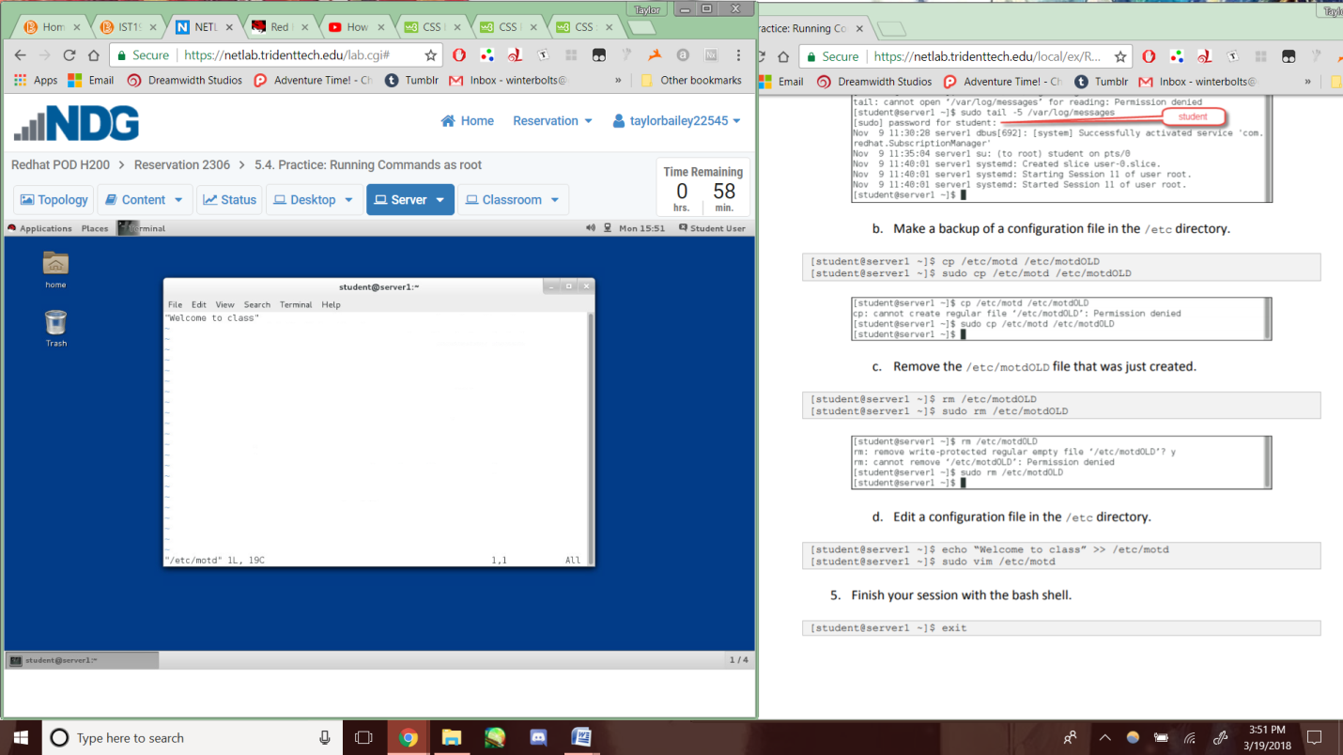

Lab3-5.6-18b

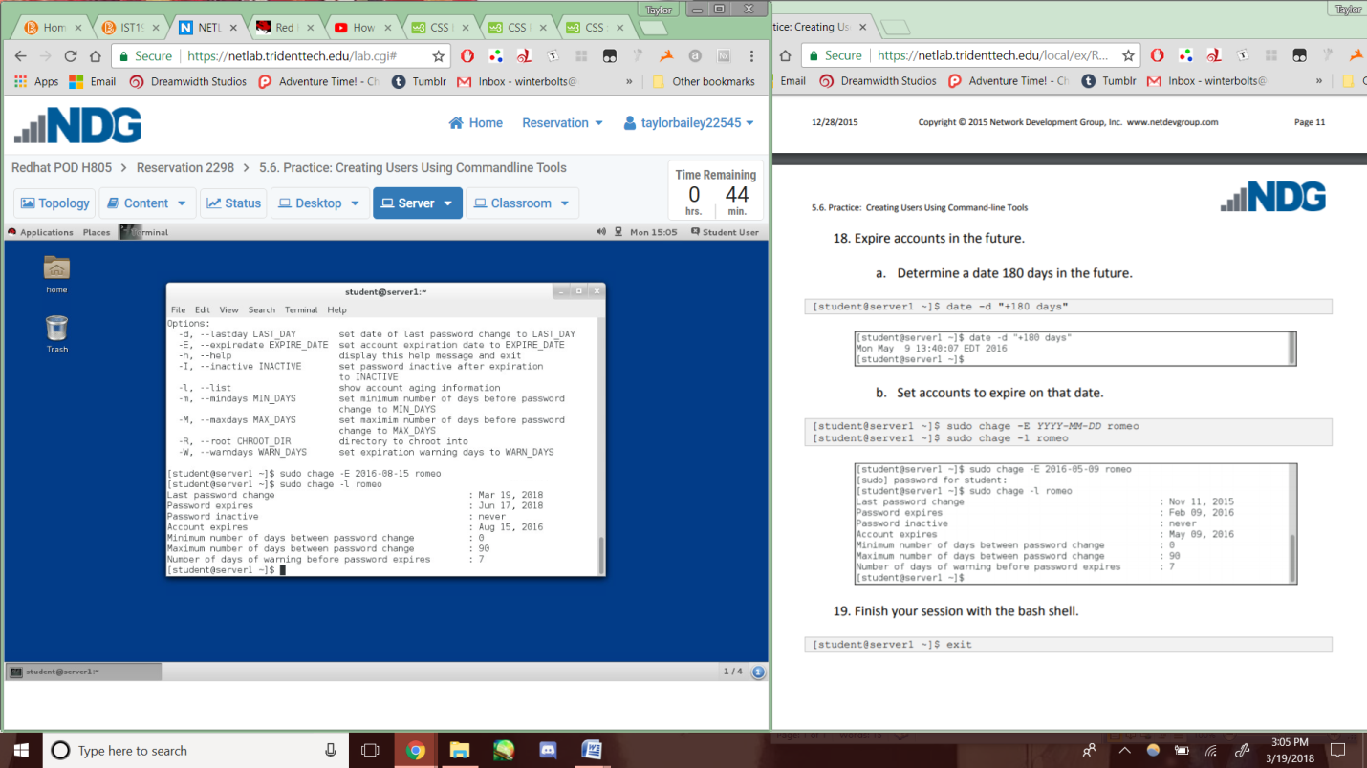

Lab3-5.11-7

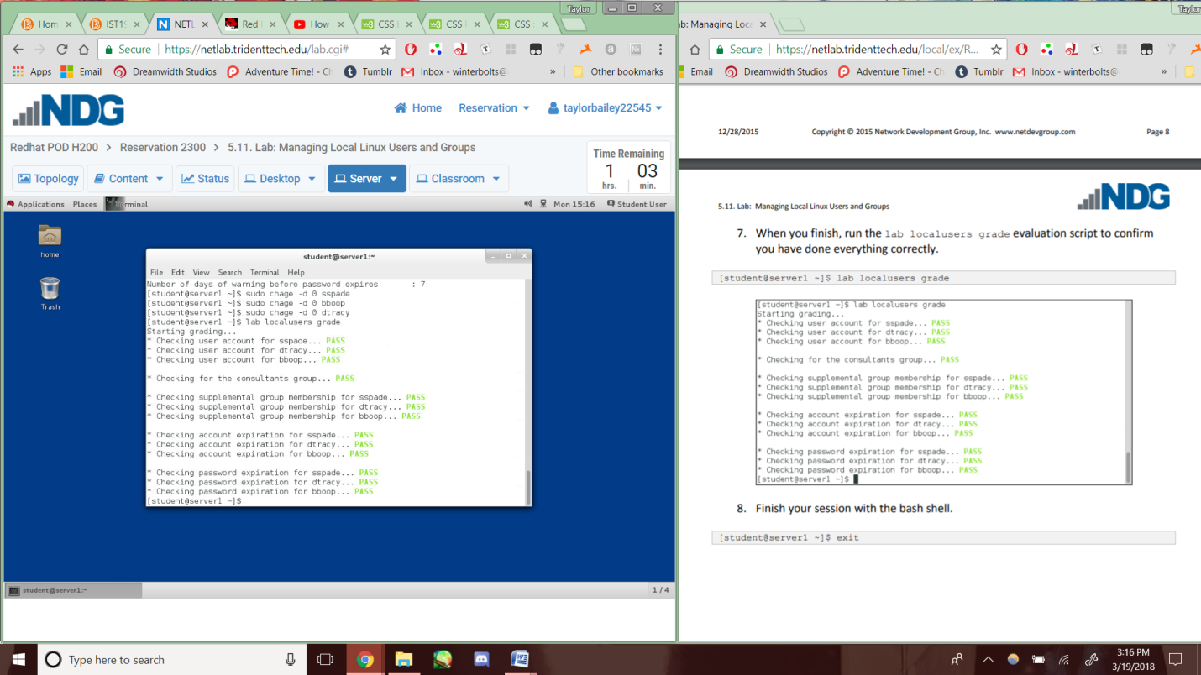

Lab3-6.4-14

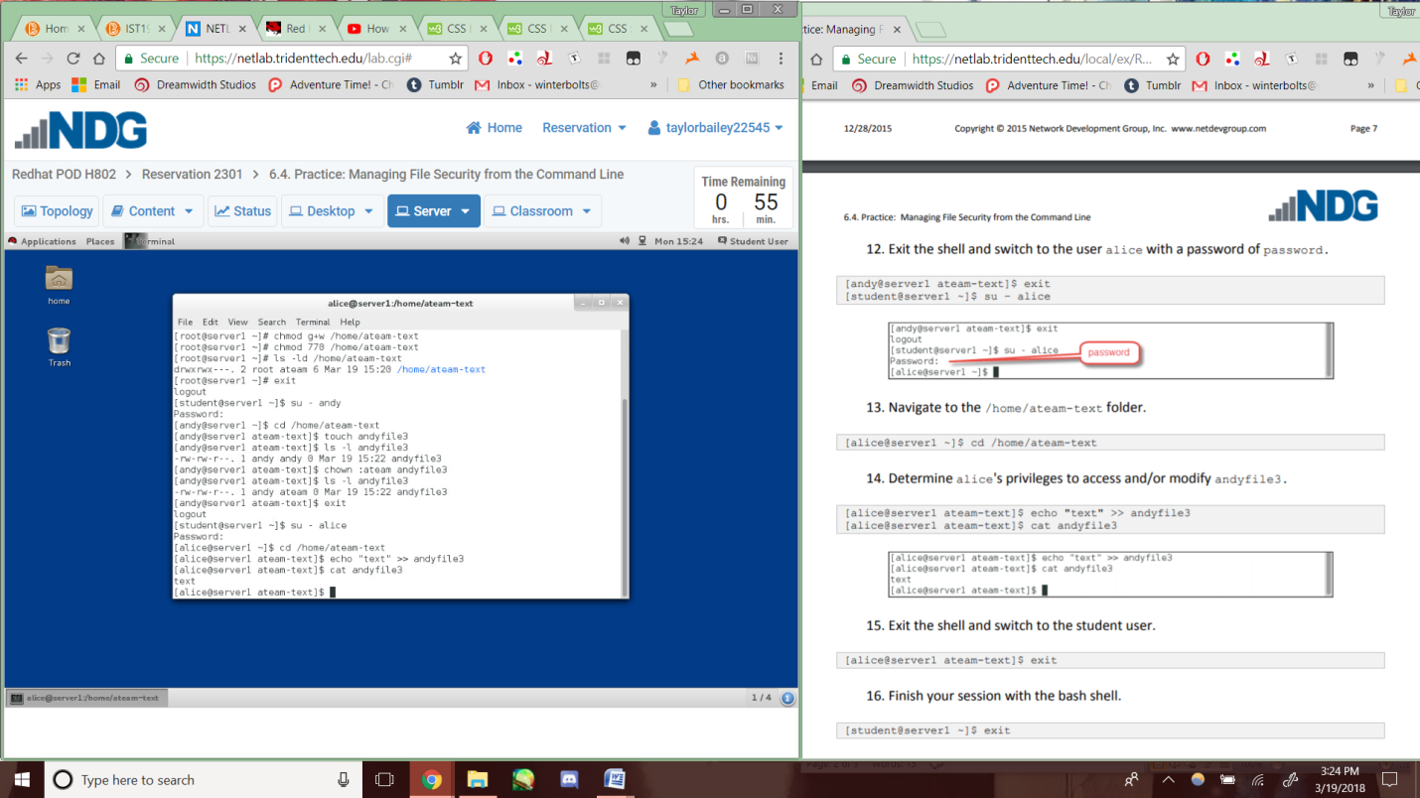

Lab3-6.6-11

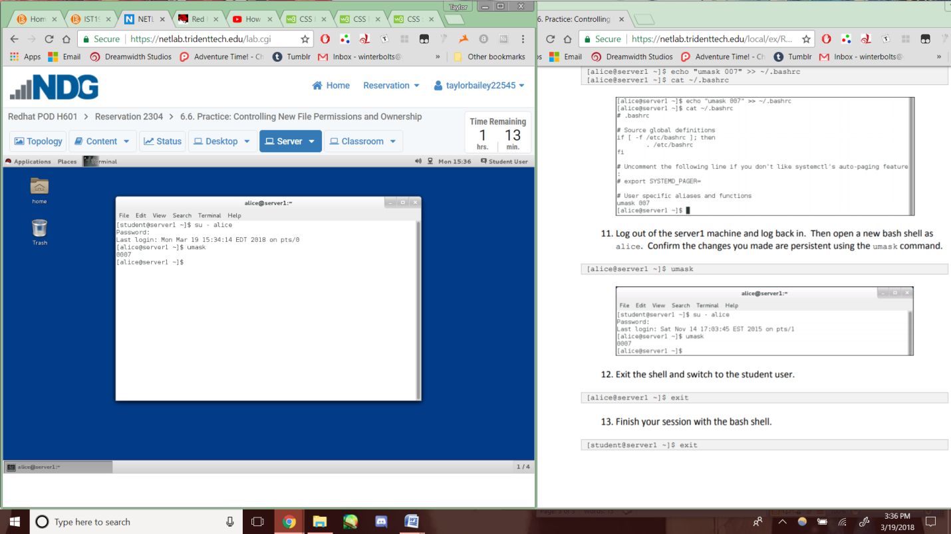

Lab3-6.7-8

